1. 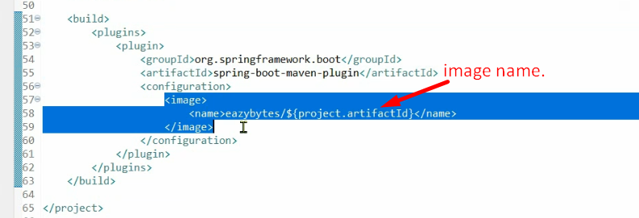
2. 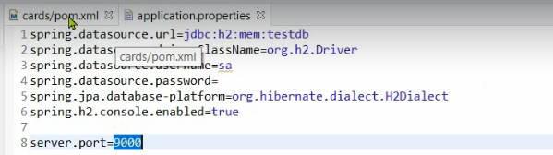
3. 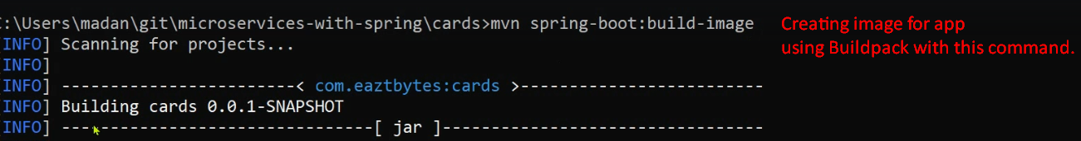
4. 
5. 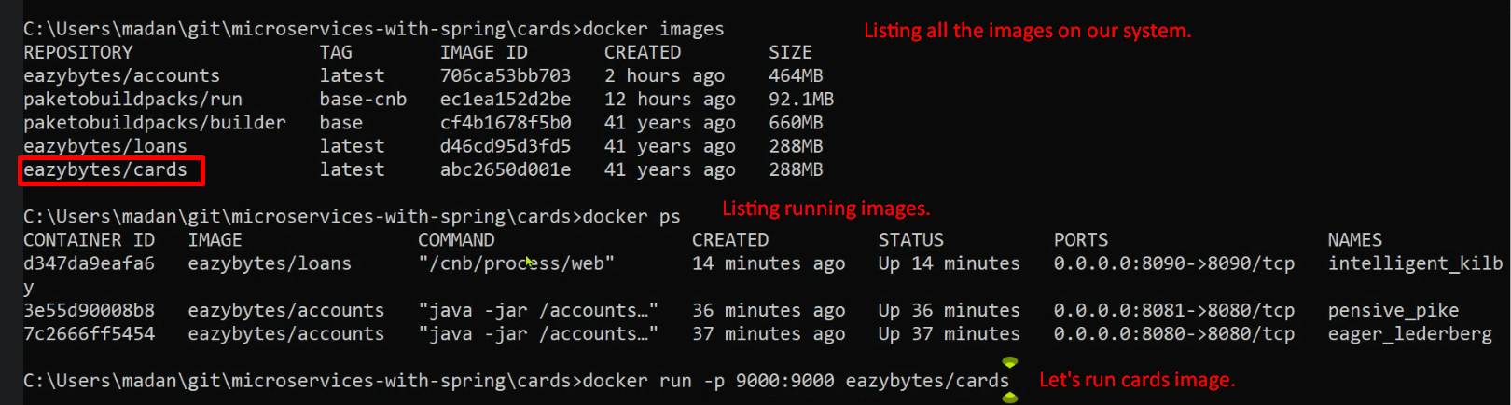
6. 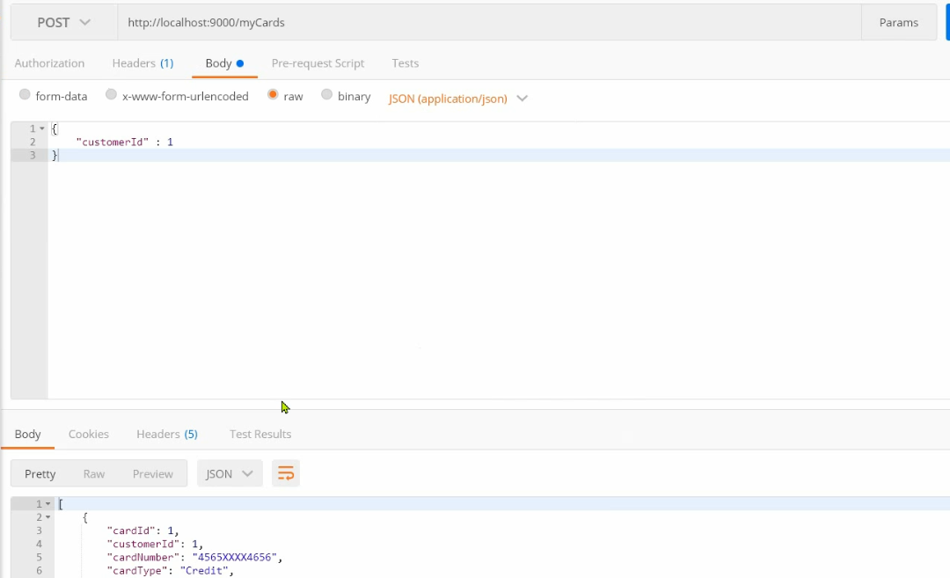
7. 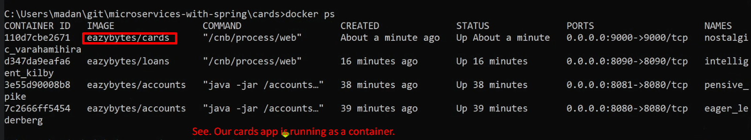
8. **Question**: We’re scaling up and down manually. Is there anyway to automate it?
9. **Answer**: Kubernetes
10. **Kubernetes**:
    1. We can create a configuration and assign to Kubernetes which handle all kinds of orchestra such as
       1. How many instances for each microservice are to be created?
       2. When a new instance for a microservice is to be instantiated such as when 70% of CPU utilization is consumed.
       3. Same when to remove an instance.  
          **NOTE**: instance means container.
11. **NOTE**: To use Kubernetes, we need Docker technologies and Docker Images.